High Level Document

**Emerging Solutions**

SALT 4.2 modifications

Version – 0.5

**29/08/2011**

Contents

1 Report pages have additional periodic scheduling controls. 2

Requirement: 2

Proposal: 2

“Report schedule “End criteria” 4

Proposed layouts for Periodic controls: 5

2. Required on Period Report screen for Org Admins 16

Requirement: 16

Proposed screenshots: 17

3 Additional fields required on Period Report screen for SALT Admins 19

Requirement: 19

Proposed screenshot: 20

4. Delete/Re-assign Reports to another user when a User is made inactive. 20

5. Allow import files to update existing users and Additional fields in import files 27

Requirement: 27

5.1 New Fields 27

5.2 Behaviour of “Update Imports” 29

6. Modifications to “My Training” page 30

Requirement: 30

Proposed modifications screens: 31

7. Provide a Rich Text editor on the existing “Org Config” screen 32

Requirement 32

Proposed Screens: 33

Requirements 33

Identified Risks 34

8. Ability to disable manager notifications at course level and to produce summaries or individual notifications. 34

8.1 Ability to disable manager notifications 35

8.2 Ability to modify notification options for each course 35

8.3 Ability to produce summaries or individual notifications. 35

8.4 Ability to produce summaries at frequencies other than one day. 35

9. Provide a feature that allows admins to temporarily stop emails. 36

10. Replace the user of the word “Delinquency” or “Delinquent” with ”Overdue”. 40

Requirement 40

11. reports are grouped by category 41

Requirements 41

Implementation 42

Testing 42

12. Historic Admin Report default date mod. 42

13. Licensing Report control changes. 44

# Report pages have additional periodic scheduling controls.

Requirement: Allow unit, organisation, and SALT admins to create periodic reports from the same screen as the manual reports for the reports given below:

* Active/Inactive Users Report
* At Risk Report
* CPD Report
* Completed Users Report
* Course Status Report
* Current Admin Report
* Licensing Report
* Policy Builder Report
* Progress Report
* Summary Report
* Trend Report
* Warning Report

## Proposal:

The above mentioned reports can be divided into 2 categories:

1. Reports having no date controls are:

* CPD Report
* Current Admin Report
* Licensing Report
* Progress Report
* Warning Report

1. Reports having 1 (Historic or Effective date) or 2 (Date from and Date to, or, Between to) date controls are:

* Active/Inactive Users Report
* At Risk Report
* Completed Users Report
* Course Status Report
* Policy Builder Report
* Summary Report
* Trend Report

The “Run Report” button will behave as it does now, it will render the Reporting Services Report in a panel that provides a toolbar containing pagination and exporting controls.

The “Reset” button beside the “Run Report” button will clear the values from all of the controls above this “reset” button.

Report Schedules will be owned by a single individual and that individual is the only Recipient on the To: list

When the Report Schedule is made inactive or the owner of the Report is made inactive the Report Schedule does not send any Reports via email until both the Schedule and the Owner of the Schedule are made active.

Report Schedules may be given a name to identify different schedules in the users list of schedules (For example ‘Quarterly Progress Summary’ or ‘Daily Progress Summary’) however the name of the Schedule does not appear in the Email that contains the Report. (The Report that is sent would typically contain a localised Report Title and Date From and Date To fields)

When “Now” is selected and the “Send” button is pressed a request to email the Report to the Report owners email address (and any other additional recipients selected as CCs) at the earliest moment possible will be queued. (A one-off Report Schedule will be created and will be processed based on relevant rules relating to priorities of Reporting Services Emails vs. user webpage requests etc. and any other devices such as “Stop mail” controls on org mail setup and mail throughput screens. The Report Schedule will not appear on any list of schedules. When the Report Schedule is processed it will be deleted. If the Reports Recipient is flagged “Inactive” at the time of processing the Schedule will be deleted without any emails being raised) The “Title” field is ignored when the “Now” Radio Button is selected – i.e. it is not saved and never appears on any emails. When a schedule is deleted no record is kept of the schedule ever having existed (for audit purposes).

When “Once only” is selected a date control is displayed and this date control must be populated before the “Send” button can be pressed (validation behaves as per all existing controls). When the “Send” button is pressed a request to email the Report to the Report owners email address (and any other additional recipients selected as CCs) at 00:00:00 in the Organisation’s Time zone on the day selected in the date control be queued. (A once-off Report Schedule will be created and will be processed based on relevant rules relating to priorities of Reporting Services Emails vs. user webpage requests etc. and any other devices such as “Stop mail” controls on mail throughput screens. The Report Schedule will appear on lists of schedules. When the Report Schedule is processed it will be deleted. If the Reports Recipient is flagged “Inactive” at the time of processing the Schedule will be deleted without any emails being raised) The “Title” field becomes the “Report Title” of the Report Schedule when the “Once Only” Radio Button is selected – i.e. it is saved as the “Report Title” of the Report Schedule however it never appears on any emails. When a schedule is deleted no record is kept of the schedule ever having existed (for audit purposes).

When “More than Once” is selected the following controls will appear:

* A “Start date” date control
* A “No end Date”-“End after”-“End On” Radio Group List of buttons
* A “Number of reports” text box (and label)
* An “End on” date control
* A “How often” text edit control and a list box containing (localized versions of) “day”, “week”, “month” and “year”.

The “Start date” date control and the “How Often” control must be populated before the “Send” button can be pressed (validation behaves as per all existing controls).

When the “No end date” option is selected no further controls need be populated and the Report Schedule can be saved when the “Send” button is pressed.

When the “end after” option is selected the user must populate the “number of reports” textbox with a positive non-zero integer before saving the Report Schedule.

When the “end on” option is selected the date control beside the “end on” option must be populated before saving the Report Schedule.

When the “Send” button is pressed a request to email the Report to the Report owners email address (and any other additional recipients selected as CCs) as soon as possible after 00:00:00 in the Organisation’s Time zone (after the overnight job has been run for that Organisation) on the day selected in the “Start date” control be queued. (A repeating Report Schedule will be created and will be processed based on relevant rules relating to priorities of Reporting Services Emails Vs. user webpage requests etc. and any other devices such as “Stop mail” controls on mail throughput screens. The Report Schedule will appear on lists of schedules. When the Report Schedule is processed it will not be deleted (unless it has met its “end criteria” – see below).

TODO: Describe the 3 options that appear on clicking “more than once” radio button

### “Report schedule “End criteria”

When SALT processes a schedule (sends emails to the active recipient and any CC: addresses) it records how many times the Report has been sent (it increments the “Number of times Report sent” counter) and the date that it was last sent (see note below) and examines the schedule “end on” or “end after” criteria to determine if the schedule has completed and should be deleted. When a schedule is deleted no record is kept of the schedule ever having existed (for audit purposes). If the user has specified “end after” N reports the schedule is deleted after that many reports have been sent, If an “end on” date has been specified the Report schedule will be deleted at (or as soon as possible after) Midnight on that date, and no reports will be generated after that date for that schedule.

The “Reset” button beside the “Send Report” button will clear the values from all of the controls between the ‘Run Report’ and ‘Send’ buttons.

## Proposed layouts for Periodic controls:

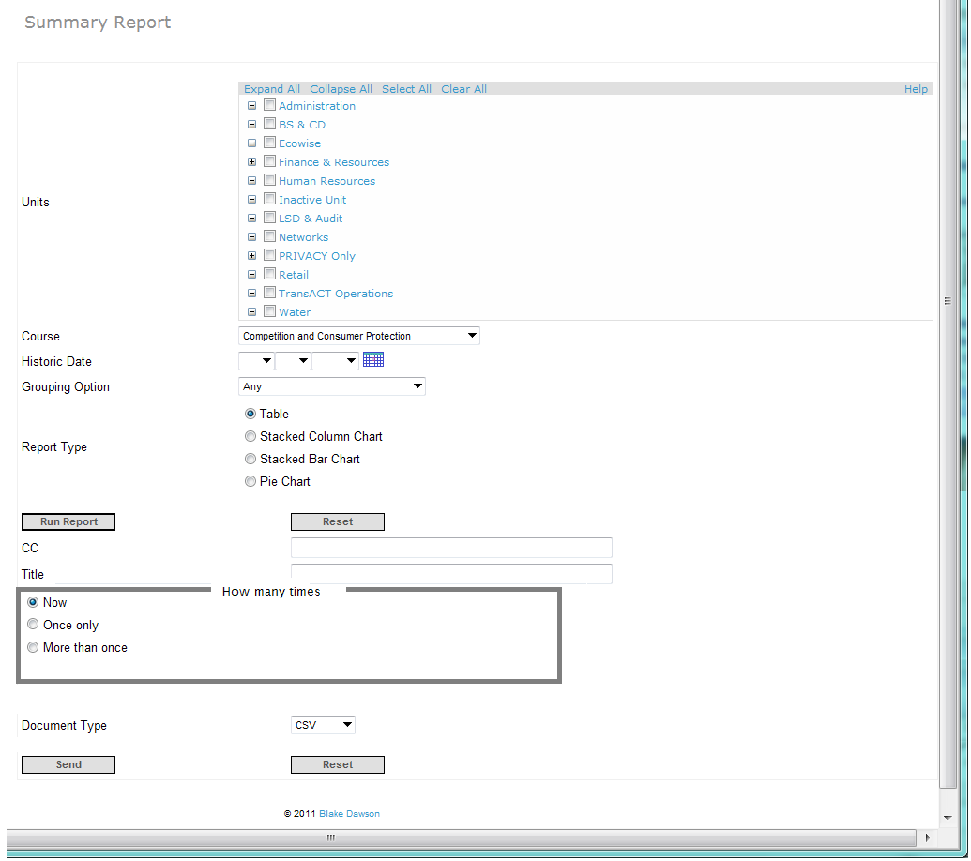

Figure "Now" option for a Report with an "Effective Date" control

For a Report that normally has one date control (Effective or Historic date), when the user selects the “Now” option the Report will be delivered by Email EXACTLY as it would be rendered to the screen if he/she had pressed the “Run Report” button so the Date control behaves EXACTLY the same.

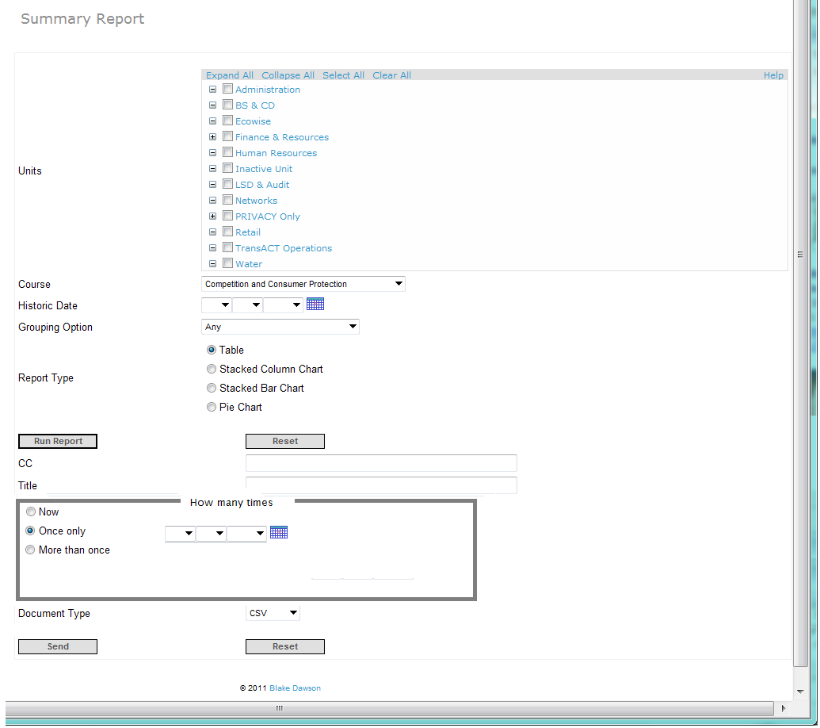

Figure "Once Only" option for a Report with an "Effective Date"

For a Report that normally has one date control (Effective or Historic date), when the User selects the “Once Only” option the Report is sent on the date specified with an “Effective Date” of 23:59:59 on the night before the Report is delivered.

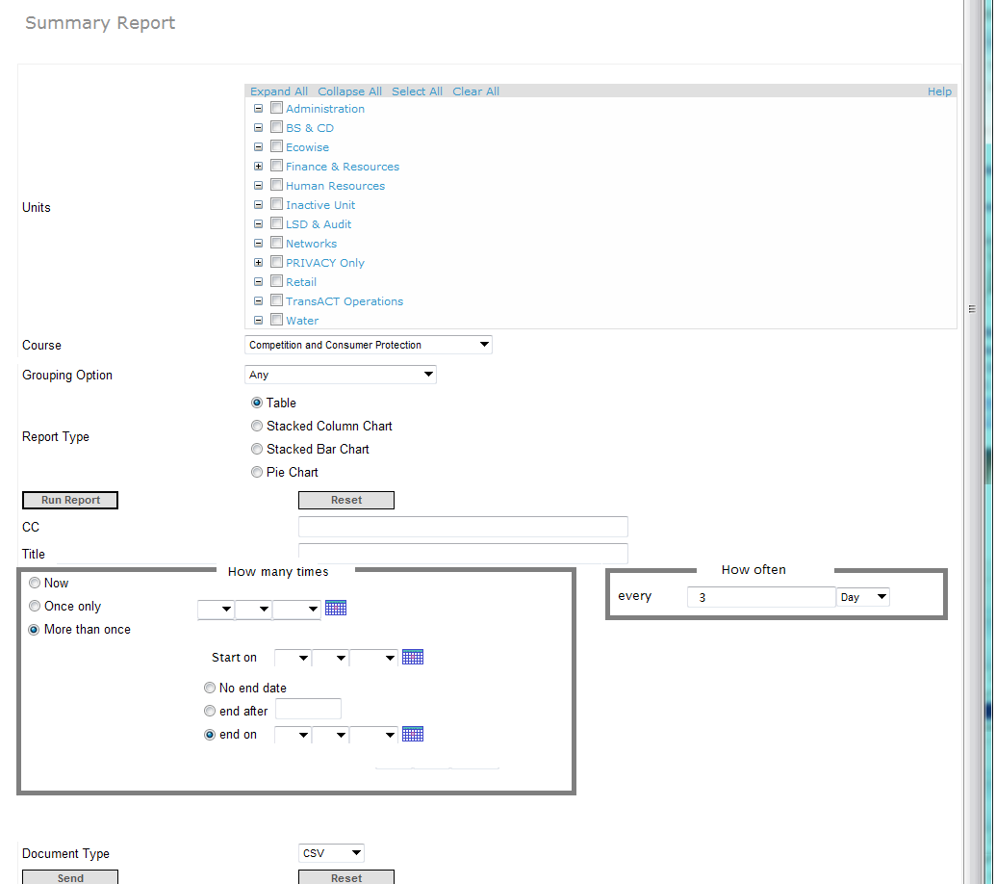Figure “More than once” option for a Report with an “Effective Date” control

For a Report that normally has one date control (Effective or Historic date), when the User selects the “More than Once” option the Report is sent at a fixed frequency with an “Effective Date” of 23:59:59 on the night before the Report is generated (delivered).

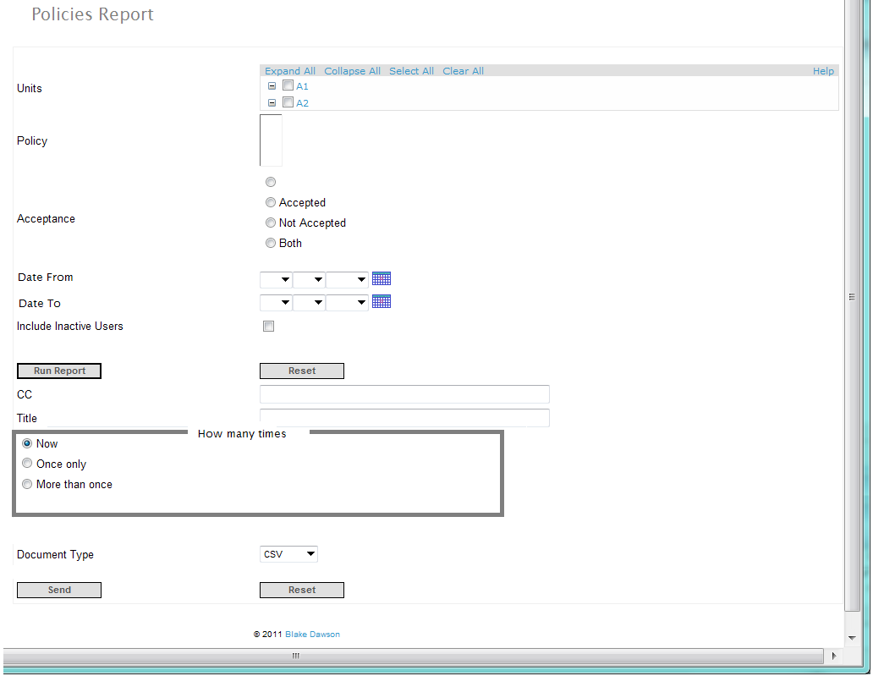

Figure The "Now" option for a Report with From and To dates

For a Report that normally has two date controls, when the user selects the “Now” option the Report will be delivered by Email EXACTLY as it would be rendered to the screen if he/she had pressed the “Run Report” button so the Date controls behaves EXACTLY the same.

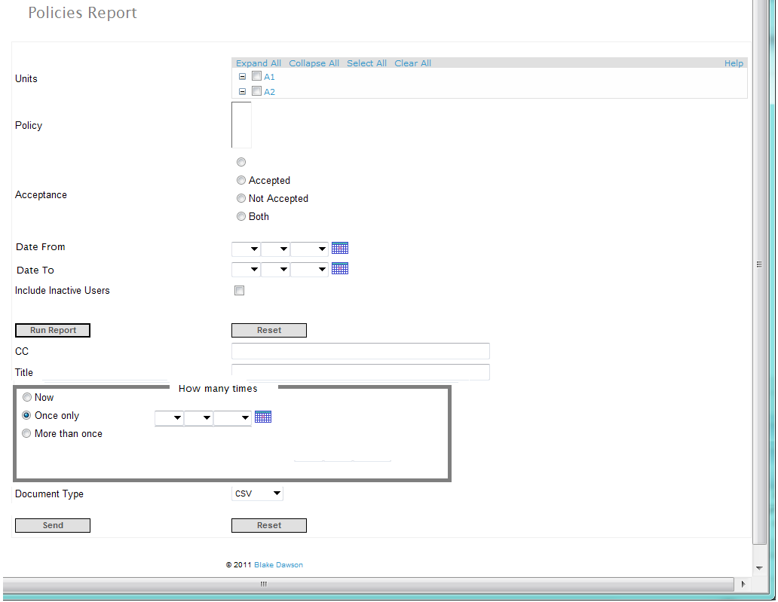

Figure The "Once only" option for a Report with From and To date controls

For a Report that normally has two date controls, when the user selects the “Once only” option the Report will be delivered on the date selected. Two additional options are available for “Once Only Two Date” Reports; these options are that the report will be generated for “All days” or “For the period from the specified date until 23:59:59 on the night before the Report is generated.

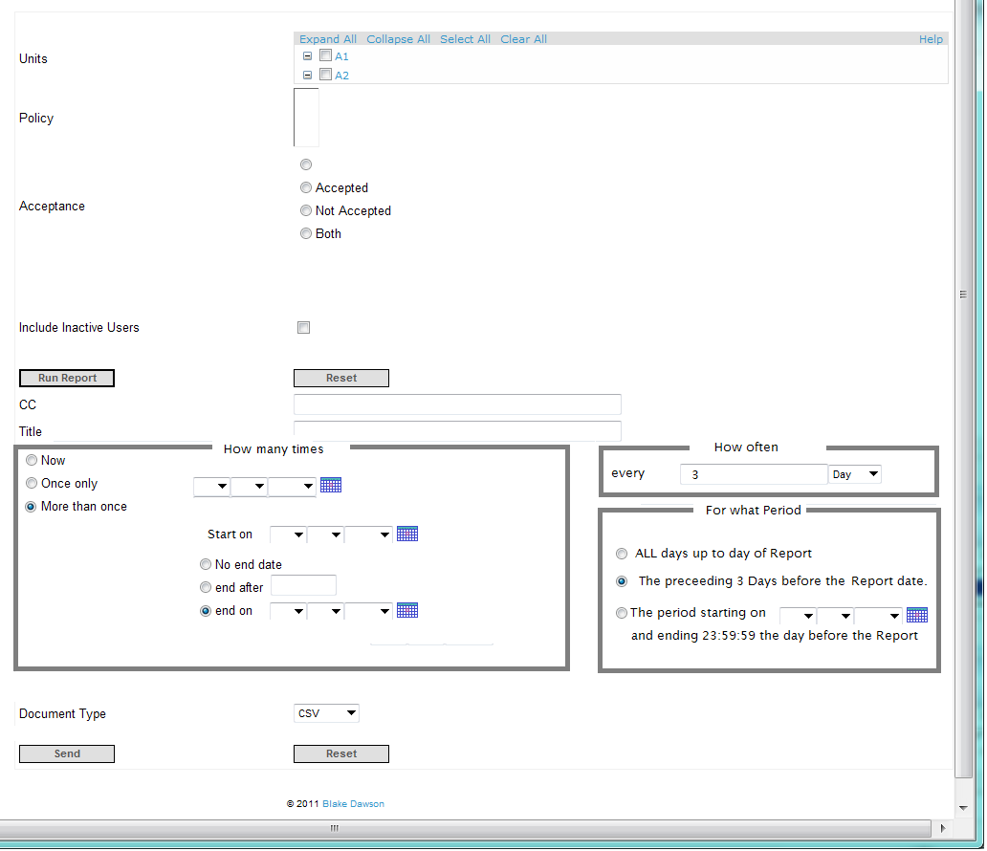

Figure The "More than Once" option for a Report with From and To date controls

For a Report that normally has two date controls, when the user selects the “Once only” option the Report will be delivered repeatedly at the frequency specified in the “How Often” control. Three options are available for “More than Once - Two Date” Reports, these options are that the report will be generated for “All days”, For the period (same period as was specified in “How Often”) or “For the period from the specified date until 23:59:59 on the night before the Report is generated.

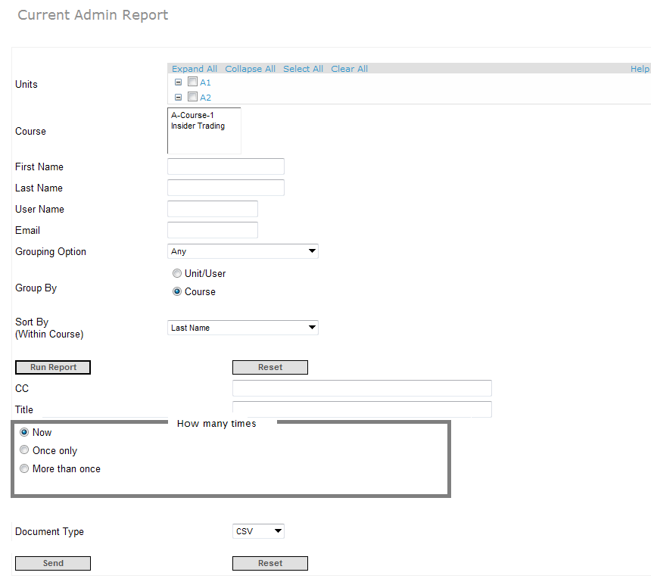

Figure The "Now" option for a Report with no date controls

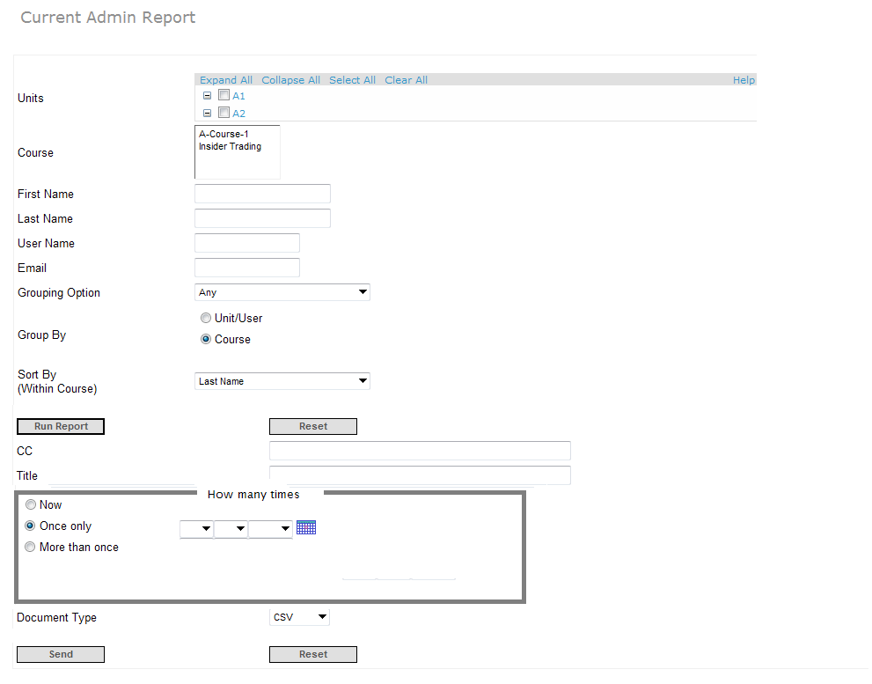

Figure The "Once Only" option for a Report with no date controls

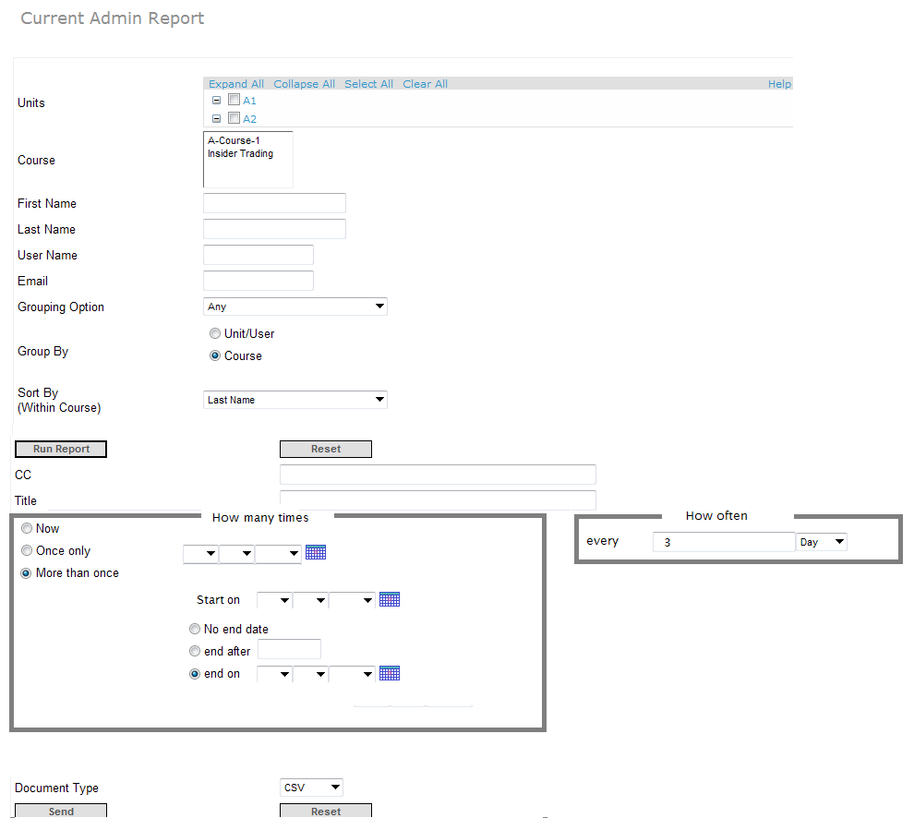

Figure The "More than Once" option for Reports with no Date controls

A Report schedule may have several CC: recipients, when a CC: recipient is inactive the other recipients will continue to receive the Reports via Email however the inactive Recipient/s will not receive the report.

A CC: field will be visible (just above the “Send” button)

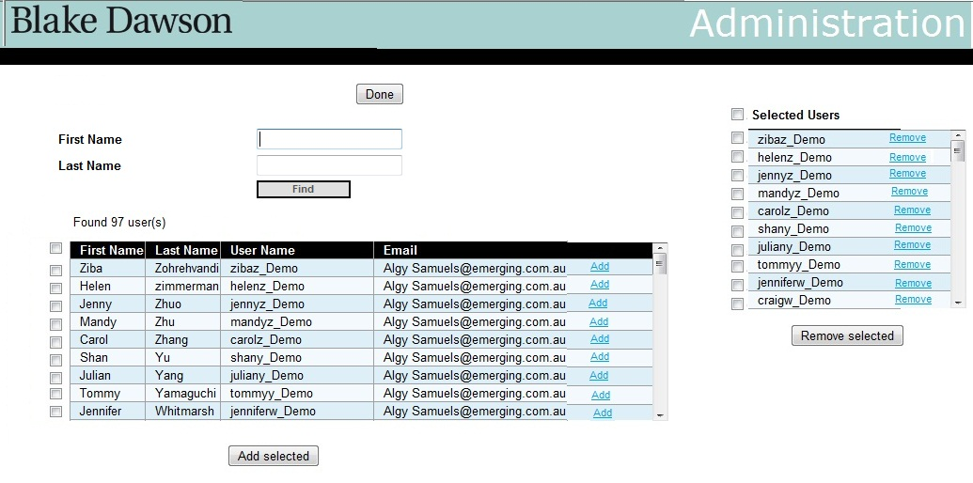

There will be an (I) shown against the users who have become inactive.

(Or does it make sense to remove the user automatically from the CC list of all reports the user is receiving when user becomes inactive?)

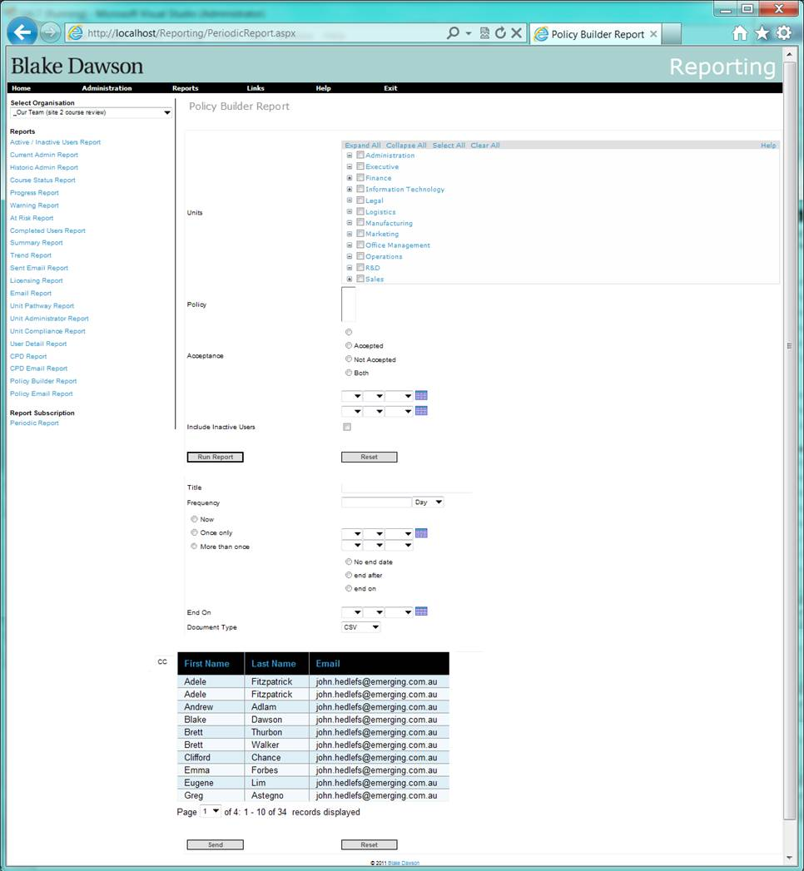

Note: non-admin users can be added to the CC list

Note: On the day the message is actually sent the application should only send the Report to ACTIVE recipients.

Note: Where the Report owner is a Unit Administrator the Report will only be generated on units that the Unit Administrator currently has permission to administer. (Even if the Report is CC’d to someone with access to more Units (or less units in the case of a non-administrator).

# 2. Required on Period Report screen for Org Admins

Requirement: Change the functionality of the new “Periodic Report Delivery” screen so that it provides the following features:

2.1 For an Org Admin a list is shown of the periodic reports created by the Unit admins or org admins in the selected organisation. It will contain the following columns:

* Non localised Report Title entered by user in users character set (Heading Localised)
* Localised Report Type (Heading Localised)
* Localised Report Frequency (Heading Localised)
* Date Created dd mmm yyyy (Heading Localised)
* Report Starts on dd mmm yyyy (Heading Localised)
* Report Ends on dd mmm yyyy (Heading Localised)
* Next date when the report will run
* Report owner
* Admin type: This will show the admin type of report owner; U for unit admin and O for organisation admin
* Non-localised “Report Delivered to” (Heading Localised). This will either contain the name of the recipient if the report is delivered to single user, or it will contain the number of recipients if the report is delivered to more than 1 user

2.2 Function to Delete/Remove selected reports

2.3 Function to Edit/Change a selected report (should return the org admin to the original screen where the report was created, with the current params/criteria filled in – do not want to be able to edit the selected report on the “Periodic Report Delivery” screen)

2.4 Function to Search/Find/Filter the periodic reports by recipient (i.e. find all reports that are being sent to a particular person)

2.5 This list can be sorted in ascending or descending order (toggled) on a column by clicking the column name

## Proposed screenshots:

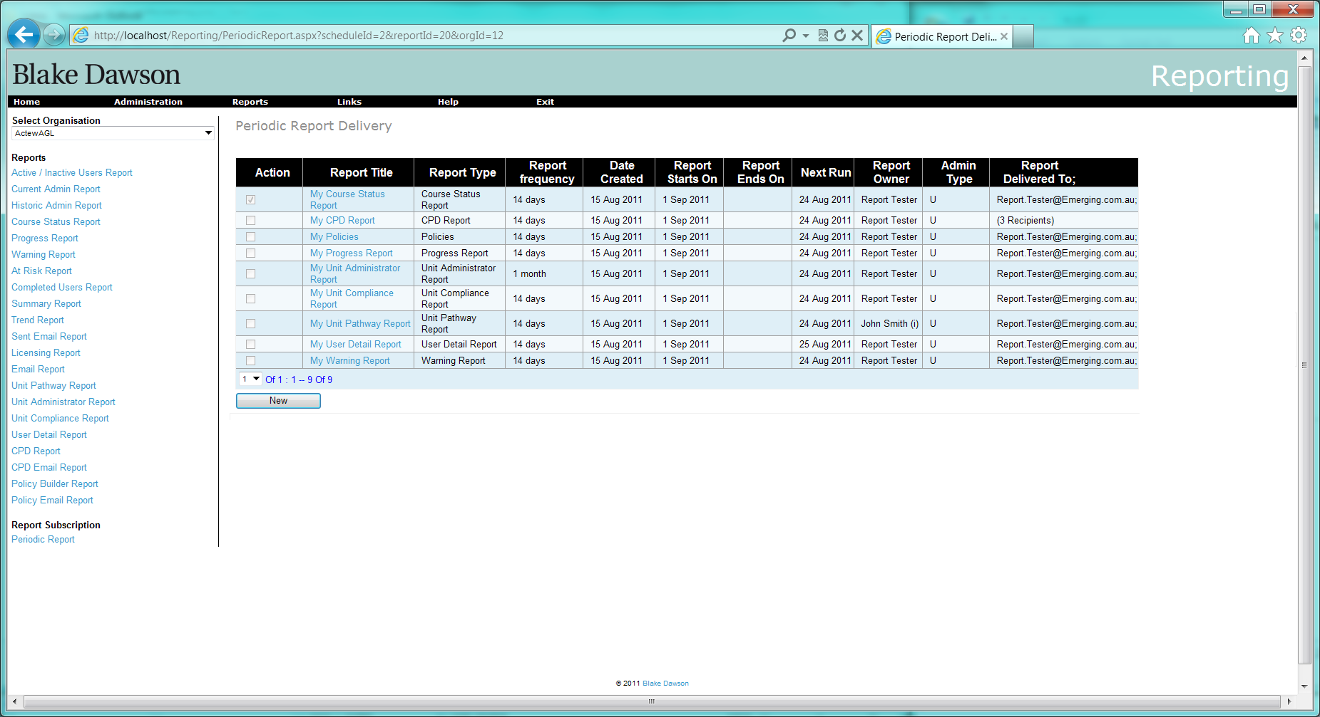

Figure 5 Period Report page (No Report Selected)

When a user selects a row the following buttons will appear:

1. Edit
2. Delete
3. Suspend

The edit button will take the user to the same Report screen as they would see if they navigated through the Report menu (i.e. the screen they created the report from)

The Delete button will delete the Report Schedule (no screen will be available to view these deleted schedules, but the record will be kept in database).

Pressing the new button will cause a “Report name” control to appear:

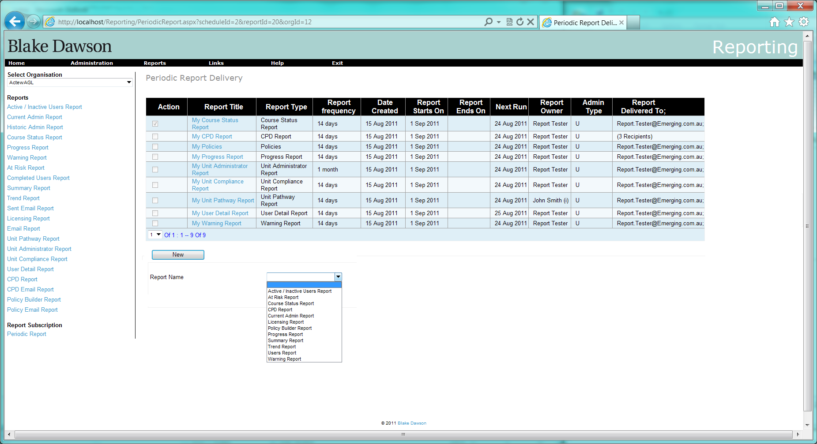

The Report Name control will be populated with the name of all Reports that the Administrator would have access to for this Organisation (in alphabetical order).

When the user selects a Report they will be taken to the Report Screen that they would see if they navigated through the Report menu.

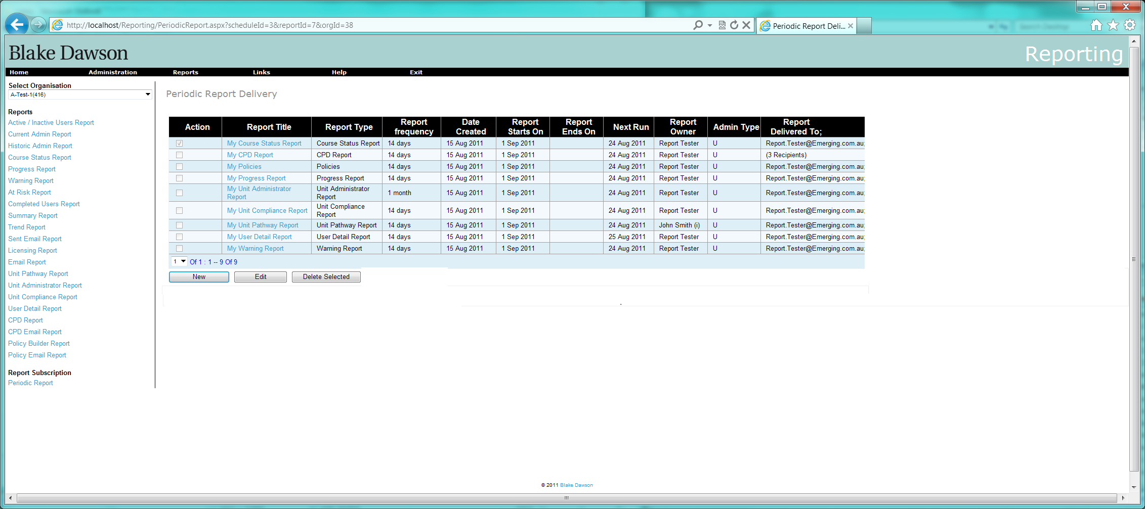

Figure 6 Periodic Report page for Org Admin (Report selected)

# 3 Additional fields required on Period Report screen for SALT Admins

Requirement: Change the functionality of the new “Periodic Report Delivery” screen so that it provides the following features:

3.1 For a SALT Admin a list of the periodic reports created by all org admins (so the salt admin can “manage” periodic reports if an org admin leaves or changes) that contains the following columns:

* Non localised Report Title entered by user in users character set (Heading Localised)
* Localised Report Type (Heading Localised)
* Localised Report Frequency (Heading Localised)
* Date Created dd mmm yyyy (Heading Localised)
* Report Starts on dd mmm yyyy (Heading Localised)
* Report Ends on dd mmm yyyy (Heading Localised)
* Next date when the report will run
* Report owner
* Admin type: This will show the admin type of report owner; U for unit admin and O for organisation admin
* Non-localised “Report Delivered to” (Heading Localised). This will either contain the name of the recipient if the report is delivered to single user, or it will contain the number of recipients if the report is delivered to more than 1 user

3.2 Function to Delete/Remove selected reports

3.3 Function to Edit/Change a selected report (should return the org admin to the original screen where the report was created, with the current params/criteria filled in – do not want to be able to edit the selected report on the “Periodic Report Delivery” screen)

3.4 The list can be filtered according to admin by a drop-down list

3.5 A check box will be provided to show all reports from all organisations

3.6 This list can be sorted in ascending or descending order (toggled) on a column by clicking the column name

## Proposed screenshot:



Figure 7 SALT Admin Periodic Report page (No Report selected)

# 4. Delete/Re-assign Reports to another user when a User is made inactive.

**Requirement:**

The admin should be notified that the inactive user was either the owner of (in the case of an org admin) or a recipient of the following periodic reports.  The admin should then be given the following choice for each periodic report that relates to the inactive user:

* + Reassign the report to another user.  If the inactive user was the owner of the report, then the selected replacement user will become the new owner.  If the inactive user was just a recipient of the report, then the selected replacement user will now receive the report instead of the inactive user (other recipients remain unchanged).
  + Delete the schedule (a Record of deleted schedules will be kept however there will be no way to view deleted schedules at this time)

There are 7 (identified) circumstances when a user’s reports may be required to be transferred to another user or deleted:

* + 1. At the time a user is made inactive (archived) from the User Details screen.
    2. At the time that the users replacement is entered into the system (may be much later after the user is made inactive) from the New User screen.
    3. At the time that the users replacement is entered into the system (may be much later after the user is made inactive) from an import (CSV or XML).
    4. When a group of users are made inactive (archived) from the Archive Users screen.
    5. When a group of users are made inactive due to an import (CSV or XML)
    6. When a SALT administrator performs maintenance on reports (to inactive users) (for example Reports that were not transferred to the user’s replacement).
    7. At such other time that a SALT administrator needs to maintain an Organisations Scheduled Reports.

There are 4 webpages where an admin can modify periodic reports:

* Make a single user inactive in the “User Details” screen
* Make bulk users inactive in the “Archive Users” screen
* Make bulk users inactive at import of users
* Revoke an Organisation admin (Remove Organisation rights of a user)
* Revoke an Unit admin
  1. On the “User Details” screen, when the admin unchecks the “User Active” checkbox and clicks “Save” button, a new screen (shown below) is displayed asking if periodic reports associated with this user should be modified.

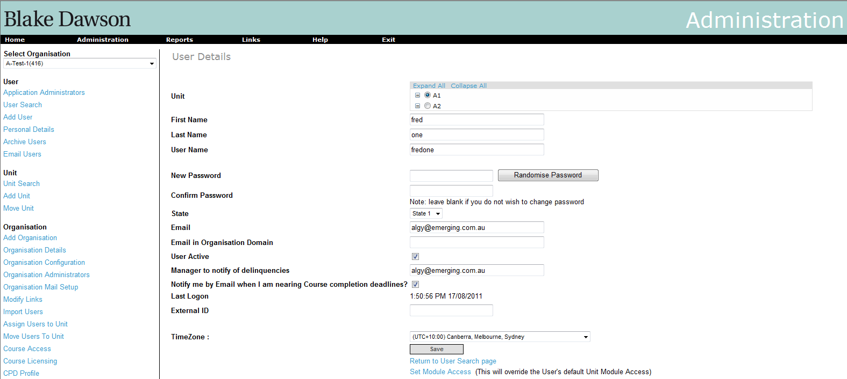

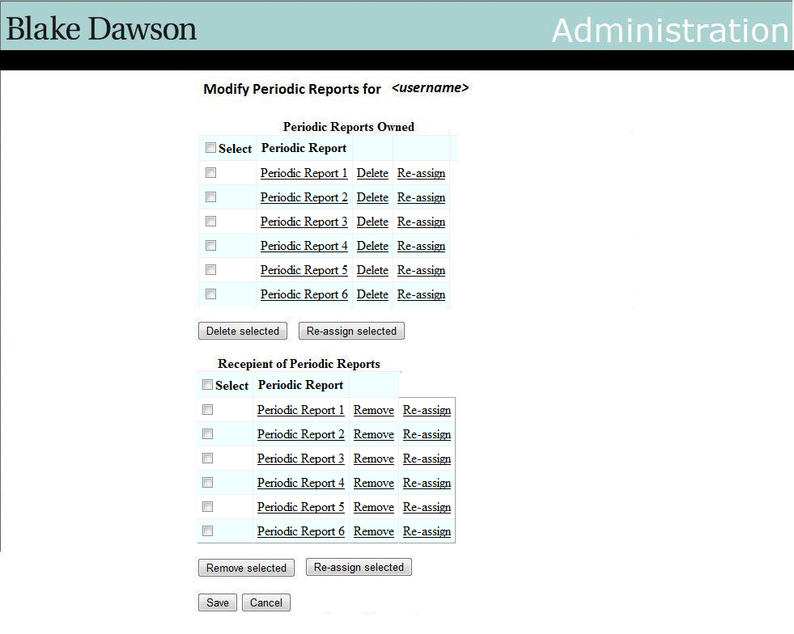

2 tables will be displayed on this page as shown in the figure above. The top table will show the periodic reports that are owned by this user. There are “Delete” and “Re-assign” buttons against each report. The admin can deleted this report or reassign the report using these buttons respectively. The admin can also select multiple reports and delete or re-assign them all by using the “Delete selected” or “Re-assign selected” buttons at the bottom of the table respectively.

The bottom table shows the periodic reports for which the user is a recipient. There is a “Remove” and “Re-assign” button against each of these reports for the admin to remove this user from the recipient list of this report. The admin can select multiple reports and remove the user from the recipient list of these selected reports or re-assign them to another user by using the button “Remove Selected” or “Re-assign Selected” respectively at the bottom of the table.

At the bottom of the screen there are buttons to save these changes or cancel the changes made and return to the “User Search” page.

* 1. On bulk archiving the users, the following screen will be shown to the admin:

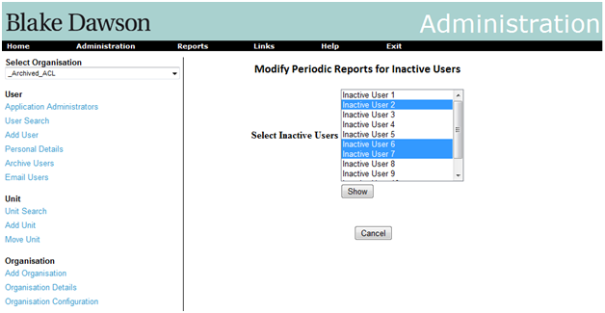

The listbox for “Select Inactive users” will be populated with the inactive users that have been archived by admin on the “Archive Users” screen. The admin can then select inactive users from this listbox and click “Show” button. This will display the 2 tables as shown below.

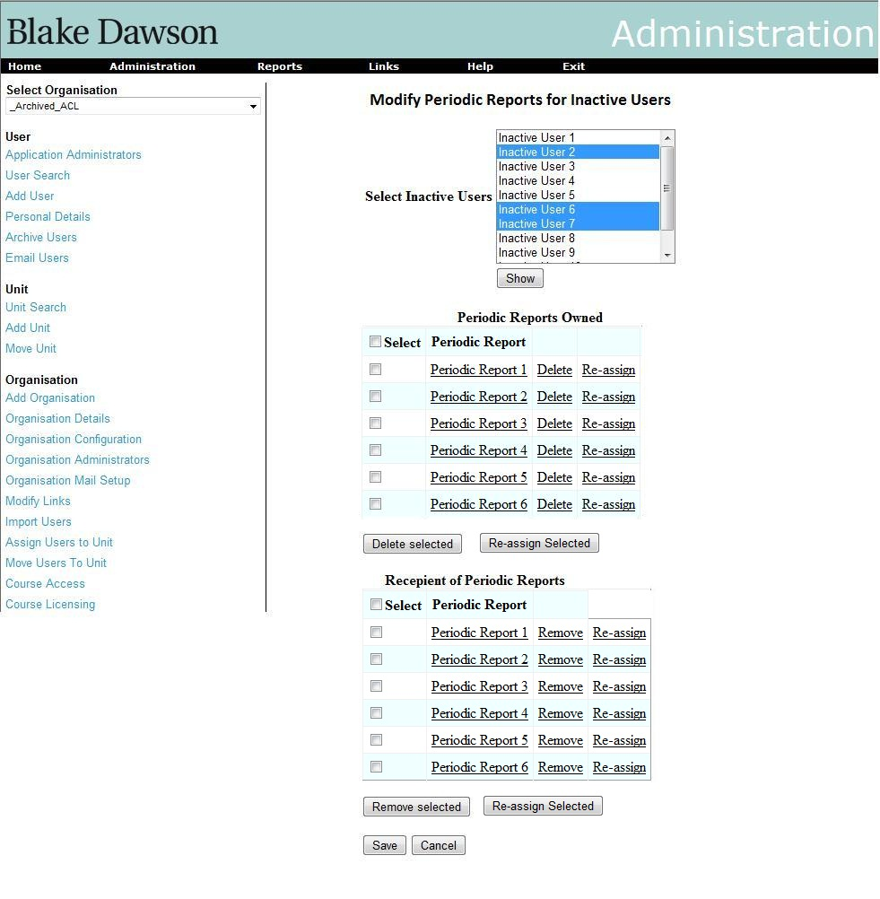

The functionality of these tables will be the same as explained in section 4.1. The only difference in this case will be that it will contain periodic reports for all the selected users in the listbox above.

* 1. For bulk import of users too, the same screens in section 4.2 will be shown. However, in this case the listbox will contain the inactive users from the imported users list.
  2. An Organisation Admin can be removed from Organisation Admin list i.e. the user’s org admin privileges are revoked from the screen shown below.

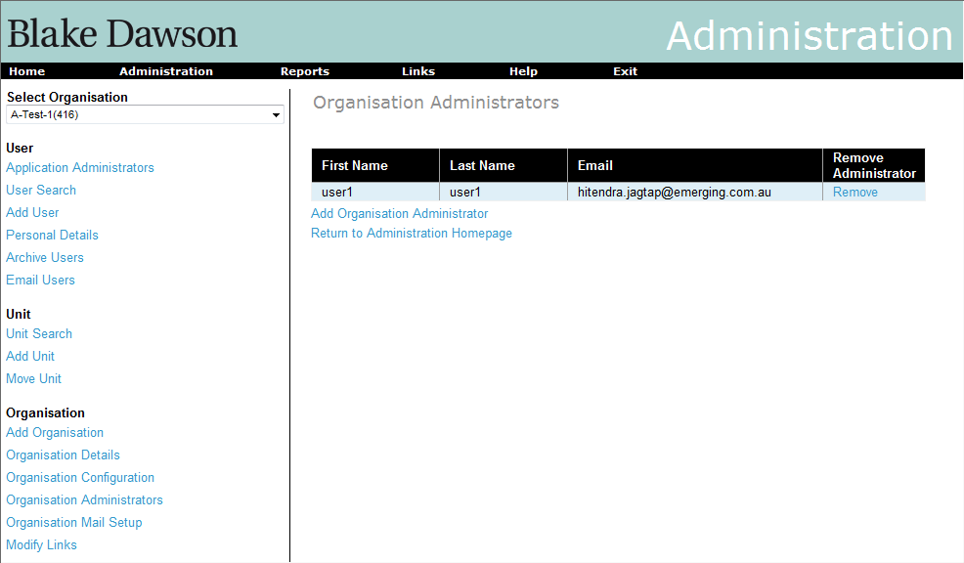

On clicking the “Remove” link in the above screen, the User will be removed as Organisation admin and a screen will pop up showing the periodic reports owned by the user and the periodic reports for which the User is a recipient. The same actions as mentioned in section 4.1 are applicable here (see the screenshot below).



4.5 A Unit Admin can be removed from Unit Admin list i.e. the user’s Unit admin privileges are revoked from the screen shown below.

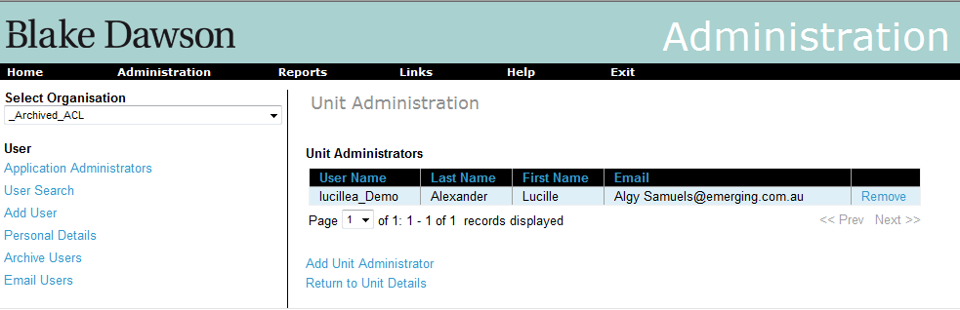

On clicking the “Remove” link in the above screen, the User will be removed as Unit admin and a screen will pop up showing the periodic reports owned by the user and the periodic reports for which the User is a recipient. The same actions as mentioned in section 4.1 are applicable here (see the screenshot below).



# 5. Allow import files to update existing users and Additional fields in import files

Requirement: Provide a bulk update feature for user imports that will allow org admins to change user values en masse without affecting existing values (i.e. update the manager’s email address for a group of users, but, don’t change anyone’s password, or give a group of users new email addresses, but, don’t change their passwords, or give a group of user new passwords, but, don’t update their email addresses, etc.).

5.1 New Fields:

* Unit Administrator
* Organisation Administrator
* Manager notification
* Manager

All of these new fields, with the exception of “Manager Notification”, specify whether delinquencies of that user be alerted by email to these roles respectively. The “Manager Notification” field contains the email id of the manager to notify.

Following is the format of CSV file that will be supported. Each of the columns here represents text that will be separated with a comma. The column names are not required to be part of the file. The columns that are greyed out are the new additions.

|  |  |  |  |  |  |  |  |  |  |
| --- | --- | --- | --- | --- | --- | --- | --- | --- | --- |
| **username** | **password** | **firstname** | **surname** | **email** | **external ID** | **unit ID** | **archive** | **group by** | **value** |
| bdawson | compliance | Blake | Dawson | [blake.dawson@bdw.com](mailto:blake.dawson@bdw.com) | 225 | 100 | 0 | Job Role | Administrator |
| bdawson |  | Blake | Dawson | |  | | --- | | blake.dawson@bdw.com | |  | 101 | 0 |  |  |

|  |  |  |  |
| --- | --- | --- | --- |
| **Unit Administrator** | **Org Administrator** | **Manager Notification** | **Manager** |
| Yes / No | Yes / No | Yes / No | =if(="Yes","Enteremailaddress",BLANK) |
| Yes / No | Yes / No | Yes / No | test.manager@testsite.com |

These fields will indicate whether the respective administrators should get the alert emails or not.

The preview will show the new fields for as per the screenshot:

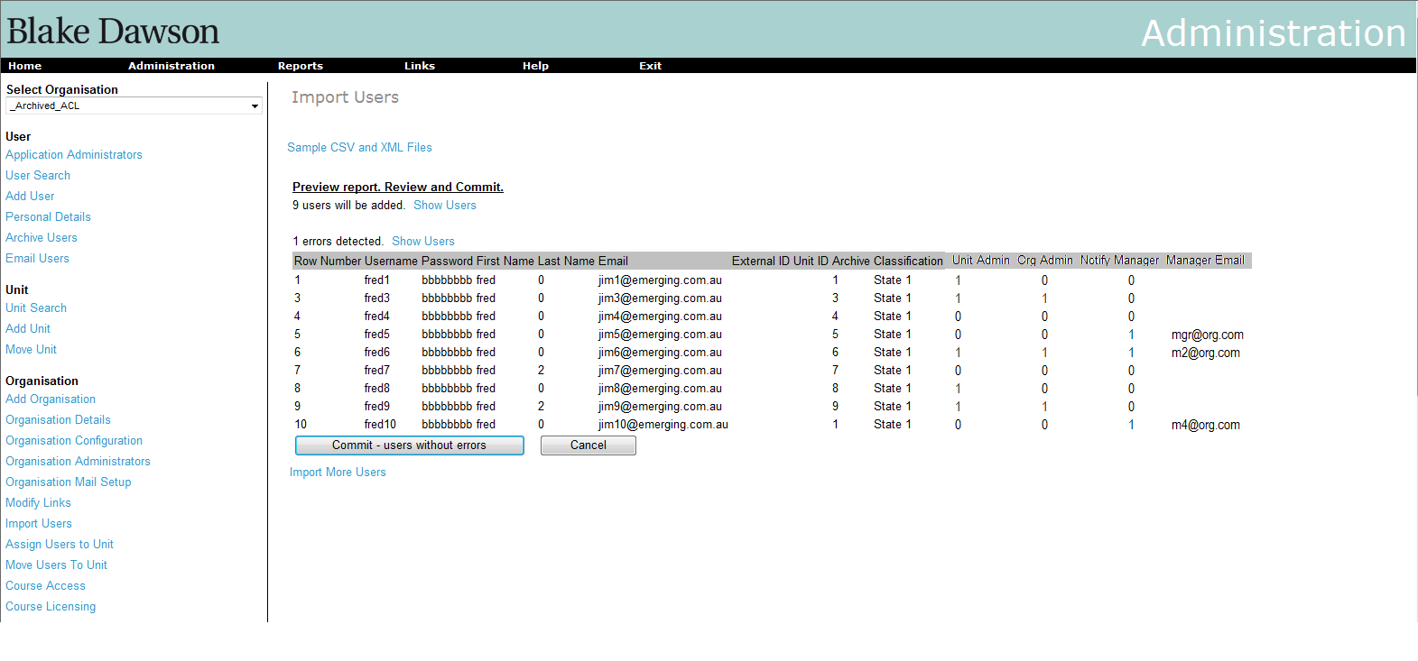

These new fields will also be added to the User Details screen. Only administrators will be able to see these new fields. Here is the screenshot of the modified User Details screen:

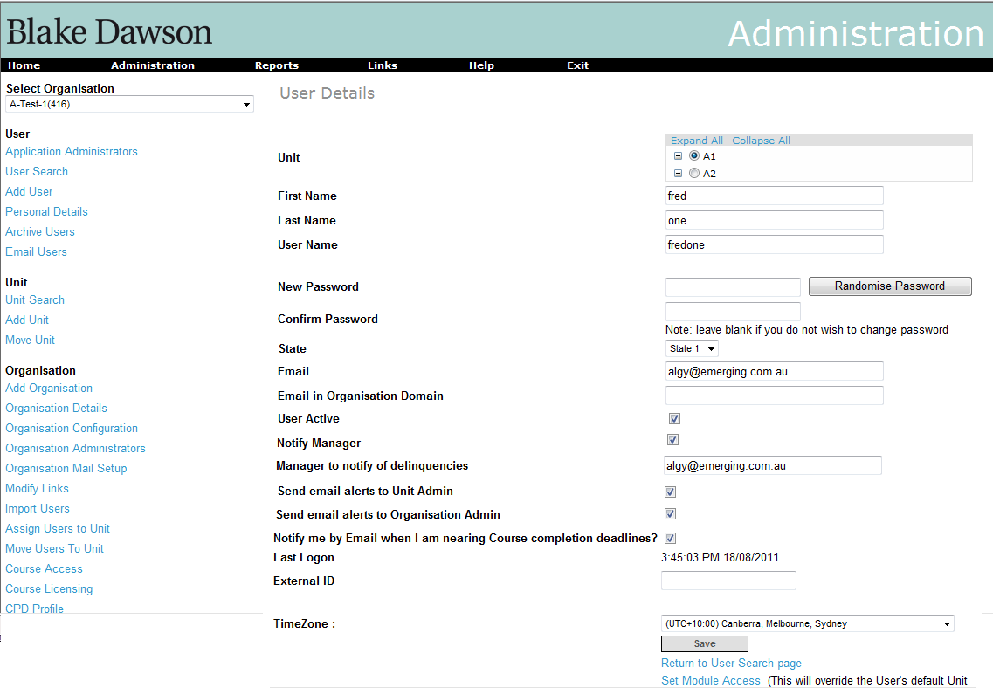

## 5.2 Behaviour of “Update Imports”

The functionality of the currently supported columns will remain the same as it is currently in SALT.

The additional functionalities will be as follows:

Currently only new users identified by the “unique field” can be added. However, now updating of existing users will also be supported. It is proposed that when two quote characters ‘’ are entered in a cell when editing the CSV file with excel the contents of the field will be deleted?

1. If a column is empty for an existing user then the value of this field will be maintained as it is currently there in the system and will not be overwritten.
2. If there is a value in a column for an existing user then the value of that field currently there in the system will be overwritten with the new value.
3. If there is a user in the imported file, which is not currently there in the system, then a new user will be created with the values of the fields as there in the imported file.
4. If there is a user in the imported file, which is currently there in the system, then the values of the fields for that user will be updated with the new values in the corresponding columns in the imported file.

In the preview screen, Instead of showing only the users that will be added and users that have errors in the import file, the users that will be updated will also be shown. The fields that are updated will be shown in a different colour. Below is a screenshot:

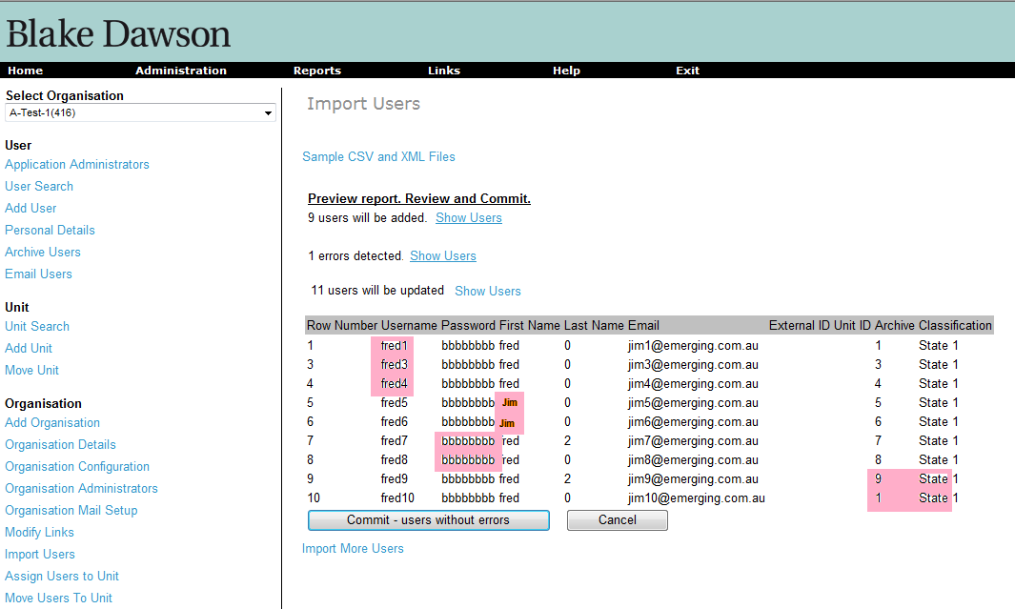

# 6. Modifications to “My Training” page

## Requirement:

The current “My Training” page shows the list of courses that are assigned to the user. It shows status i.e. whether the course has not been attempted, or is in progress, or has been completed. Please see the screenshot below:

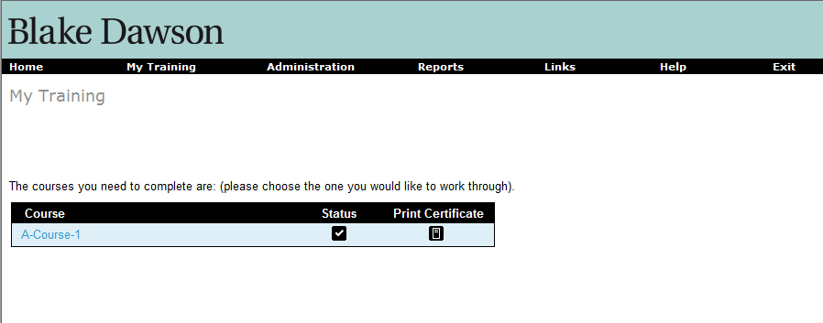

On clicking on the course the list of associated modules are displayed. The status of the lessons and quizzes in the modules are displayed as icons as shown below.

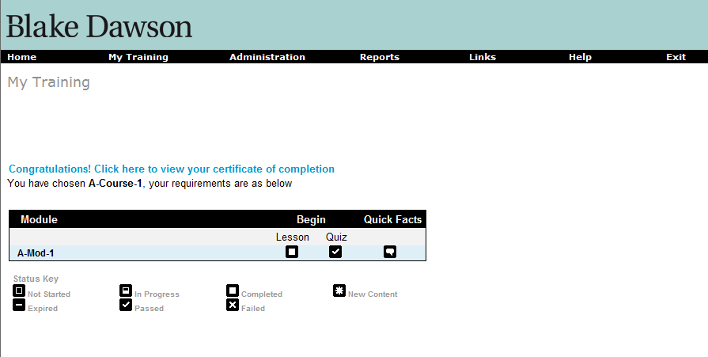

## Proposed modifications screens:

The “My Training” page with courses will show 2 more columns as shown in below screenshot. The “Due Date” column shows the date when the user is Overdue or the number of days until it becomes overdue. The colour of the text will be red and BOLD if the due date has passed. The “Last completion date” column shows the last date when the course was completed by the user. It is assumed that it will be useful to know when the certification for the course is expiring.

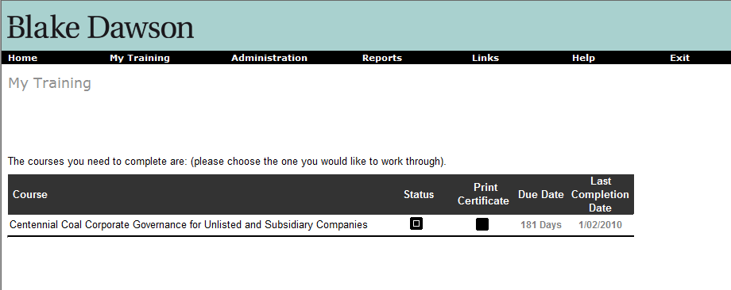

The “Modules” screen will have 2 more columns for the modules as shown below. The “Last pass date” will show the date when the user has last completed the module and passed the quiz. The “Quiz due” column will show the due date for passing the quiz or the number of days before it expires. The colour of the text will be red and BOLD if the due date is in the past.

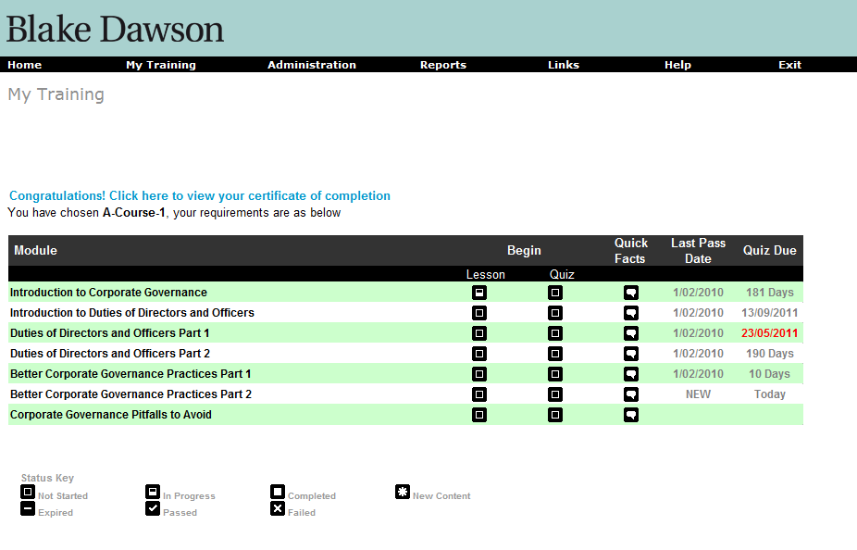

# 7. Provide a Rich Text editor on the existing “Org Config” screen

Requirement: Provide a Rich Text editor for each email template on the existing “Org Config” screen that allows org admins to define HTML email templates rather than just plain text email templates.

## Proposed Screens:

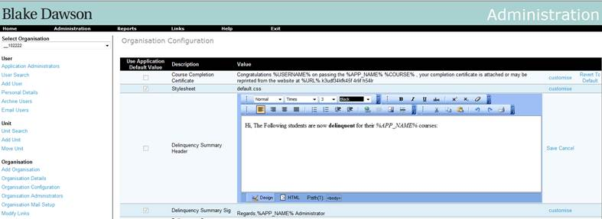

Figure 9 Organisation Config Screen (Editing - i.e editor visible)

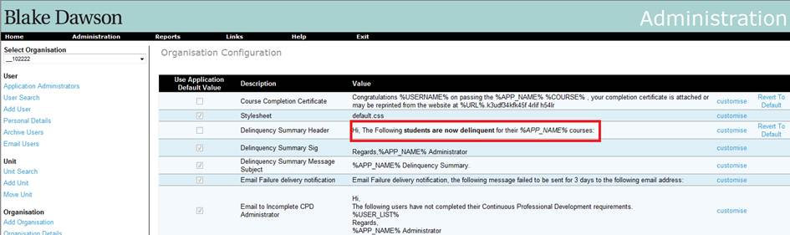

Figure 10 Organisation Config Screen (Not editing)

# Requirements

To add the ‘customise option’ for message that has already been customized:

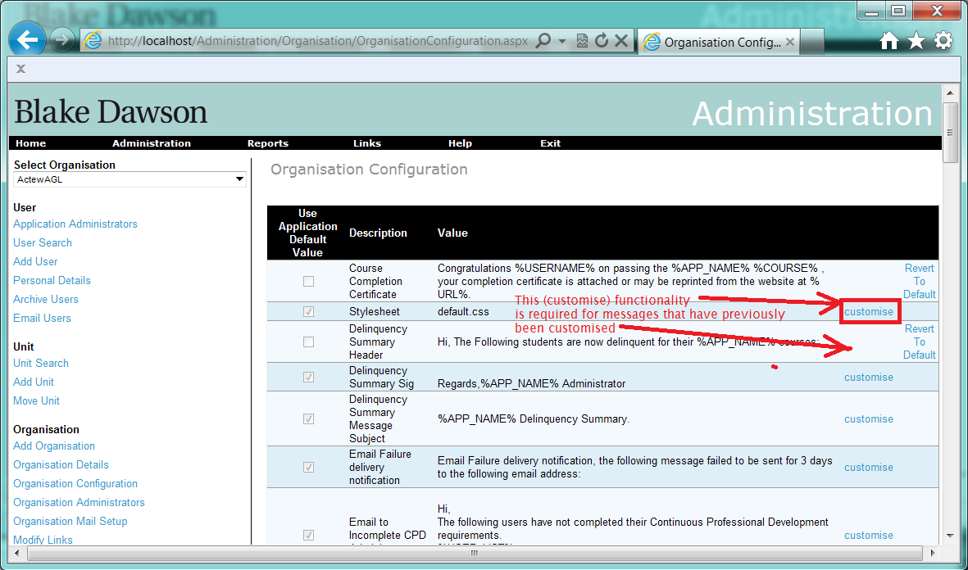

# Identified Risks

The risk is when the outcome is the condition where there are two versions of a customized message for one organization. In this case, several ASP pages may error on loading as the SQL on those pages is written to handle (at most) one customised message.

# 8. Ability to disable manager notifications at course level and to produce summaries or individual notifications.

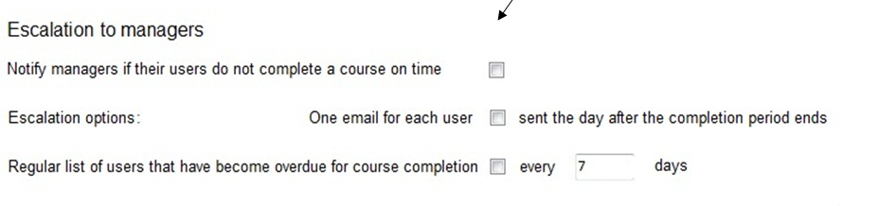

For each course in the Organisation the Administrator may define how the Overdue Emails will behave. The Manager may choose to have

* no Overdue emails sent
* One email per user
* A summary every N days

## 8.1 Ability to disable manager notifications

The Mail Queueing service will not create Overdue summaries for courses in the Organisation flagged as “no Overdue emails sent” however the service will set flags such that if the “no Overdue emails sent” is unset in the future the manager will not receive emails for the period when “no Overdue emails sent” was set.

## 8.2 Ability to modify notification options for each course

The default options will be for no notification for a course so the user must modify the “Course Expiry” Mail options for a course before managers will receive notifications for that course.

A separate email will always be sent for every course.

## 8.3 Ability to produce summaries or individual notifications.

The services will be modified to allow individual emails to be sent.

## Ability to produce summaries at frequencies other than one day.

# 9. Provide a feature that allows admins to temporarily stop emails.

Sometimes the number of emails being sent may be too much for the system to handle. In such scenario, the organisation admins and the SALT admin should be able to temporarily disable all emails either for the organisation or for the **entire** site.  This should not just stop the mail sending service, thereby allowing emails to queue up whilst it’s disabled, which may result in a mail storm when the sending service is re-enabled – it should delete all existing emails that are currently queued . This will apply not only for the emails send via “Mail sending service”, but also to the ad hoc emails sent by the application.

To enable this functionality, there will be a button on the “Organisation Mail Setup” screen for the Organisation admin to stop emails for their organisation. The screenshot for this is shown below:

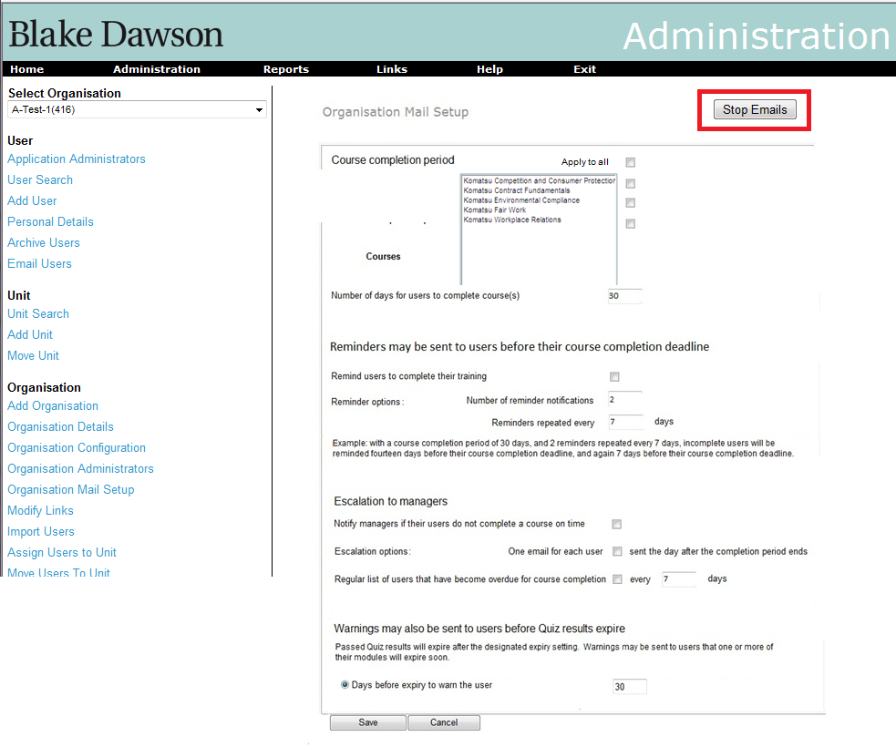

Along with this, the SALT admin will have an additional button on the “Mail Throughput” screen. This will stop all emails sent by the entire site (see the screenshot below).

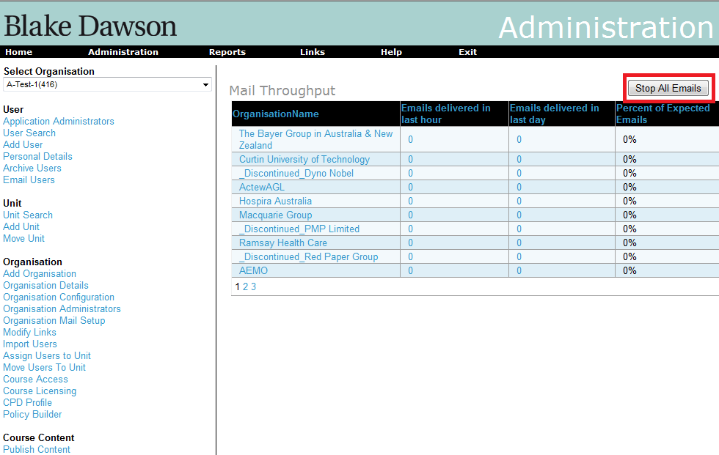

These buttons can be toggled, meaning once pressed they would provide option to enable sending the emails again.

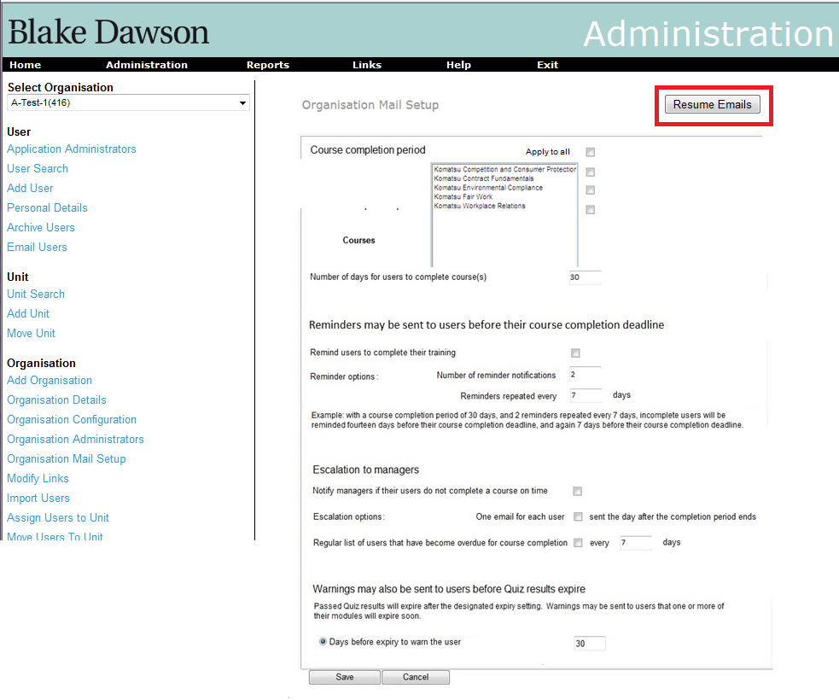

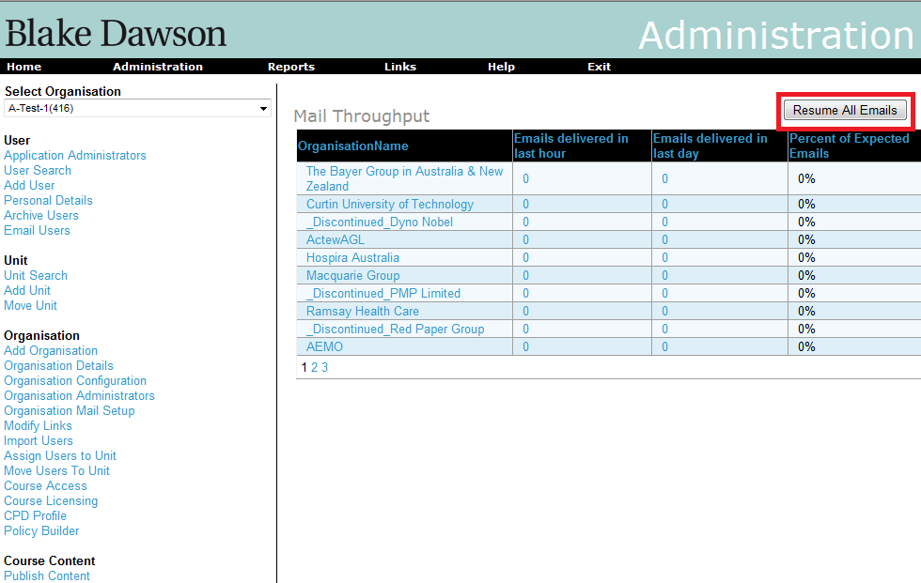

However, the dropped emails will not be re-sent. Even though emails will be created, queued and deleted from the application during this period when the “Stop Emails” button is pressed, they will be maintained in database for audit purpose.

Audit tables for sent Emails and Deleted Emails do not/will not contain Attachments.

To reduce load on the Report Server during the time that the “Stop Emails” button is pressed requests to render the reports (for Emails that will be deleted) will not be made and the body of the deleted Email will simply contain the name of the Report that should have been rendered and the unlocalised string ‘deleted’.

The only Emails that will be stopped during the time that the “Stop Emails” button is pressed are Emails that are generated by the Mail Sending Service and the Mail Queueing Service, Emails generated directly from ASP pages will continue to be sent.

# 10. Replace the user of the word “Delinquency” or “Delinquent” with ”Overdue”.

Requirement: Replace the user of the word “Delinquency” or “Delinquent” with Overdue.

The phrase “At Risk of Delinquency” will be replaced with the phrase ”At Risk of becoming Overdue”.

# 11. reports are grouped by category

## Requirements

To modify the Salt4.2 Report menu so that reports are grouped by category as per the following table.

|  |  |
| --- | --- |
|  |  |
|  |  |
| **User Activity Reports** | |
|  | Current Admin Report |
|  | Course Status Report |
|  | Completed Users Report |
|  | At Risk Report |
|  | Warning Report |
|  | Progress Report |
|  | Historic Admin Report |
|  |  |
| **Organisation Reports** | |
|  | Summary Report |
|  | Trend Report |
|  |  |
| **Email Reports** | |
|  | Email Report |
|  | CPD Email Report |
|  | Policy Email Report |
|  | Sent Email Report |
|  |  |
| **Administration Reports** | |
|  | User Detail Report |
|  | Active / Inactive Users Report |
|  | Licensing Report |
|  | Unit Pathway Report |
|  | Unit Compliance Report |
|  | Unit Administrator Report |
|  |  |
| **CPD Reports** | |
|  | CPD Report |
|  |  |
| **Policy Reports** | |
|  | Policy Builder Report |
|  |  |

All category names will be localized (with the English version of the localization supplied)

When an Organisation does not have CPD access neither the “**CPD Reports**” category or the “CPD Report” link will be visible.

When an Organisation does not have Policy Builder access then neither the “**Policy Reports**” category or the “Policy Builder Report” link will be visible.

# Implementation

The 6 category names must be created in the localization tables for the GLOBAL.UserControls.ReportsMenu.ascx interface.

Changes will be made to ReportsMenu.ascx to display the labels.

Changes will be made to ReportsMenu.ascx.cs to hide the categories when they should not be visible.

# Testing

Testing should be done in all user contexts:

* Student
* Unit Admin
* Org Admin
* App Admin

# 12. Historic Admin Report default date mod.

The “Historic Date” on the Historic Admin Report will default to yesterday.

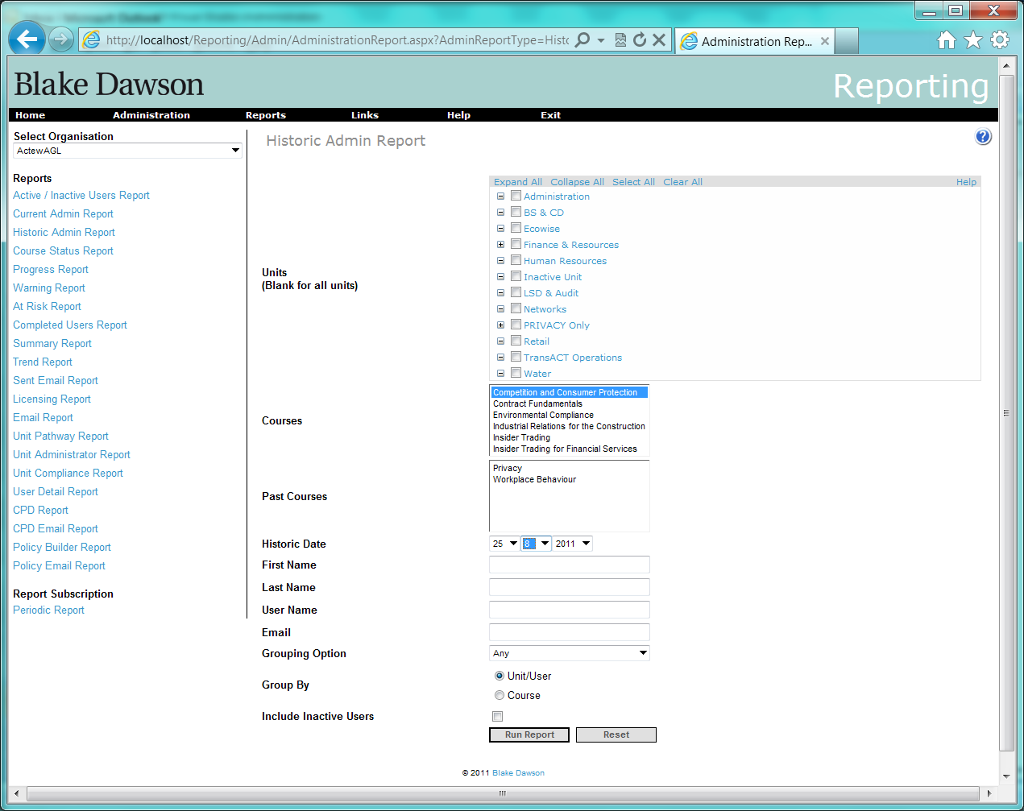

# 13. Licensing Report control changes.

The grid on the Licensing Report will be modified as shown: 